Global Consciousness Project:
Exploratory Block Analysis of the
Columbia Space Shuttle Disaster

Bryan J. Williams
Department of Psychology
University of New Mexico
Albuquerque, NM 87131

Abstract

Previous exploratory analyses of the data collected by a continuously running, globally-distributed network of random number generators during several major world events as part of the Global Consciousness Project (GCP) suggest that several different structural patterns within random data can be revealed with varying segment size, or “blocking.” Further exploration of this was carried out using the GCP data corresponding to the tragic loss of the Space Shuttle Columbia and its 7-member crew on February 1, 2003. It was found that 15-minute blocking of the data reveals graphical trends somewhat similar to that seen in standard seconds resolution, along with what appears to be stronger, transient deviations surrounding the event that, while most are not statistically significant, are nonetheless interesting. An attempt at inter-node network correlation produced a null result. Several issues regarding blocking such as signal detection, artifact vs. psi effect, and trend interpretation are discussed in light of these results.

Introduction

The tragic loss of the Space Shuttle Columbia and its crew of seven astronauts when it had suddenly exploded upon atmospheric reentry from space on the morning of February 1, 2003 was an event that had captured the attention of many Americans and again spread feelings of deep sorrow all across the country. Based on the fact that some of astronauts aboard were from other countries (one of the flight engineers had been born in India and another was an Israeli fighter pilot who became the first from his country to go into space), it was thought that the impact of the event would spread beyond the United States, and that some degree of worldwide attention and sorrow would be shared. Thus, it was thought that this tragedy had the markings for a global event that would possibly draw out a form of shared global consciousness.
The Global Consciousness Project (GCP) had been formed in 1998 by Roger Nelson with the intent of attempting to detect possible signatures of this ostensible global consciousness during major events that capture the attention and the emotions of the world through the monitoring of the first Internet-based, globally-distributed network of electronic, truly random number generators (RNGs). The general hypothesis is that when major world-affecting events occur, the behavior of random physical systems is briefly perturbed through a form of shared mind-matter interaction in conjunction with the focused attention of the global population and the emotions elicited in response to the events. This is based on previous experimental research that revealed negentropic directional trends in RNG output that correlates with subject mental intention (Jahn et al., 1997; Radin, 1997), and subsequent field research using portable RNGs that revealed significant randomness deviations during social events that drew mass attention and shared group interaction (Nelson et al., 1996, 1998 a, b; Radin, 1997). Since its inception, the GCP has produced highly significant cumulative results suggestive of some sort of statistical anomaly (Nelson, 2001; Nelson, Radin, Shoup, & Bancel, 2002).
One issue to arise from the results is the degree of resolution that is optimal for detecting the observed deviation signal. Previous GCP explorations of this using varying data segment lengths seemed to produce differing perspectives on the trend behavior, causing the result to sometimes shift from initial nonsignificance in seconds resolution to significance in 15-minute resolution (e.g., Nelson, 1999a). There are several smaller issues that come out of this, the first being that of artifact vs. genuine signal. It would seem that grouping data into equal time segment periods (i.e., “blocking” the data) can be quite useful in providing additional perspectives on the data trends, in that it could collectively strengthen a weak signal spread out across time that would otherwise go undetected in standard seconds resolution. Previous experimental research on mind-matter interaction effects indicate that the effects are often times very weak and subtle signals that tend to emerge from the background noise only after a large number of trials has been gathered and collectively examined (Jahn et al., 1997; Radin, 1997), and if global consciousness effects involve many of the same processes as intentional mind-matter interaction effects, the same limitations might apply to them. On the other hand, it is equally possible that blocking might very well inflate the actual trend and therefore produce statistical artifacts that turn out to be significant when they are really not (i.e., “false signals”). Recent GCP analyses as of 2000 using unblocked, real-time data suggest that not all of the observed signals in the data are likely to be statistical artifacts (one alternative way proposed to explain the results), as the anomalous trends still often appear where they are predicted to be, yet the possibility exists that some of the events for which null results were found might actually have weaker, time-varying trends that were so subtle that they were undetectable using seconds resolution, and thus some of the events might have only seemed to have random walks when we would not expect them to, when in fact the trend was unobservable because the data were not blocked. Thus, there remains to be some degree of “give and take” that comes with blocking, and it deserves further study.
A second issue that arises is the correlation between the degree of emotional impact from the event and the presence of an anomalous signal. The results of a previous field RNG study conducted in a therapeutic setting suggested that there is a unique correlation between the outpouring of emotions and directional deviations from randomness in a nearby RNG, with anger and aggression correlating with a positive deviation, and anxious crying correlating with a negative deviation (Blasband, 2000). From this, it can argued that global consciousness may largely involve mass emotional reactions to events, and that a shared emotional outpouring may be what is correlated with many of the significant results found in the GCP database. In the formal analysis of the Columbia disaster, this did not seem to be the case, as the trend was near baseline throughout the formal prediction period and were only slightly consistent with the emotion-deviation correlation by displaying a negative trend towards the end, possibly reflective of the wide sorrow and mourning for the astronauts who perished (Nelson et al., 2003).
There are a number of GCP events within the database similar to the Columbia disaster that seem to be consistent with the emotion-deviation correlation, however. The nationwide sorrow over the loss of John F. Kennedy, Jr. in a plane crash in July of 1999 seemed to be reflected in the network of RNGs (called “EGGs”) during the time of a public mass in New York, and an interesting “earth consciousness” reaction at the moment of the crash seemed to display a potentially meaningful response (Nelson, 1999b). The four-hour aftermath of the Concorde crash in Paris on July 25, 2000 that became world news first showed a very strong positive deviation from chance, which then sharply reversed midway through the prediction period into a strong negative trend (Nelson et al., 2000a). Concern over the safety and survival of the Russian naval men aboard the submarine Kursk after it had exploded and sank in August of 2000 seemed to be reflected in the EGG data to a suggestive degree, displaying a growing positive trend that began with the explosion and carried on into the first few days of waiting for word of the situation (Nelson et al., 2000b). The crash of American Airlines Flight 587 in Queens, NY on November 12, 2001 had resulted in a sharp downward trend that leveled and remained low throughout all of the formal prediction period, seemingly in line with the fears of many people that another terrorist hijacking had occurred aboard a commercial airliner (Nelson et al., 2001). The plane crash that took the life of Senator Paul Wellstone on October 25, 2002 had seemingly brought about a very strong trend among the EGGs positioned within the United States, which appeared to be reflective of the widespread grief among Americans upon hearing the news (Nelson, 2002). And of course, there is September 11, 2001, an event in which some of the strongest deviations in the history of the GCP were seen throughout the network, and these deviations extended over the course of two days, which was much in line with the sustained shock, fear, and grief that resonated throughout the world in the days following the tragedy (Nelson et al., 2002).
An exploratory block analysis was carried out on the EGG data corresponding to the Columbia disaster to supplement the results of the formal GCP prediction analysis (Nelson et al., 2003), as well as to examine the two above issues in further detail, the result of which may be useful in generating future hypotheses to be tested with blocked data and in future GCP events that could be predicted to show some degree of emotion-randomness deviation correlation. An additional exploratory block analysis of a related event, a major memorial ceremony for the astronauts held at the Johnson Space Center in Houston, TX which involved the participation of families of the astronauts, NASA staff members, and several dignitaries including President Bush, and was broadcast nationally on television, was also carried out to look for any randomness deviations in the data that may be correlated with the feelings of sorrow that was likely to have been shared by many during the ceremony. Recent GCP and field RNG explorations of funeral and memorial services suggest that even these events can sometimes show significant deviations from randomness (Nelson et al., 1998a; Williams, 2002), but that this is not always the case (Nelson et al., 1998b). Thus, it was thought that this event might also serve as another informal test in determining the kinds of emotional events that tend to show group consciousness effects.

Method

The details of the EGG network components and the formal procedures used by the GCP have been described in detail elsewhere (Nelson, 2001; Nelson et al., 2002), and so only the methods used in the present study will be described here in full. The daily summary files for February 1, 2, and 4, 2003 were first downloaded from the GCP website (http://noosphere. princeton.edu). The files are in table form, where columns represent the data from the individual EGGs reporting on the given day, and rows give the synchronized time in Universal Coordinate Time (UTC). The data that corresponded with U. S. Central Standard Time (CST), which given current time changes is 6 hours behind UTC, were then extracted and used for the analysis. The formal prediction for the Columbia disaster that was entered in the GCP Prediction Registry lists the specified analysis timeperiod as 8:00 A.M. - 12:00 P.M. Eastern Standard Time (7:00 - 11:00 A.M. CST, or 13:00 - 17:00 UTC), which begins one hour before the disaster (pre-event period) and ends three hours following it (aftermath period), with predictions for deviations from randomness occurring within this timeframe as the news of the disaster spreads. The same timeframe was used in the analyses carried out in the present study, in block periods of 15-minutes. In addition, a context examination of the entire day of February 1 in CST was conducted for further exploration. Three types of analyses were carried out on the data: cumulative deviation of Chi-square, block period odds ratio, and inter-EGG correlation.

Cumulative Deviation of Chi-Square

The cumulative deviation of Chi-square is the primary analysis method employed by the GCP, and was therefore meant to also act as the primary measure of the deviation from randomness for this study. The daily summary files come in the form of block Z-scores, which are obtained by the following method: the raw individual output of each EGG is the sum of 200 binary number samples per second, with equal distributions of “1”s and “0”s being the expected outcome at chance, given a truly random system. The measure of the mean deviation from chance expectation for each EGG over 1 second is computed as a normalized z-score in the form , where x is the number of observed trial “1”s, 100 is the mean number of “1” bits expected by chance, and 50 is the trial sum variance (Aron & Aron, 1997; Nelson, 2001). For each EGG, we then compute a block Stouffer’s Z over a 15-minute period (900 seconds) as

Z
=
z
i
i
=
1
900
Σ
900

which are then in the form found in the daily summary files (Nelson, 2001). We then square these Z-scores to create a 15-minute block deviation value for each EGG with 1 df that is Chi-square distributed. Since Chi-square values are additive, we can sum these values across EGGs and across time, with df = (# of 15-minute blocks) × (# of active EGGs). This procedure effectively responds to the variability among the EGGs of the network.

Block Period Odds Ratio

The block Z-scores in the daily summary files can also be collapsed into a single value representative of the composite deviation value for the entire network over one 15-minute block period by computing a second Stouffer’s Z, with which a block period odds ratio can be obtained. First, all of the Z-scores in the files are sign corrected based on the given “1”s obtained in the 15-minute period out of the total number of trials for each EGG (~ 180,000). The Stouffer’s Z is then computed across all the active EGGs as

Z
block
=
Z
i
i
=
1
N
Σ
N

where N is the number of EGGs reporting for every 15-minute interval. We can then calculate a probability value for this block Z, from which we can compute the associated odds against chance. This method was first used in an exploratory analysis of a related sorrowful event (the accidental death of a friend of the author) as a means of further insight, with promising initial results (Williams, 2002).

Inter-EGG Correlation

An alternative to the standard Chi-square approach for detecting anomalous deviations is to examine for correlated deviations between the individual EGGs in the network. Given that the EGGs are separated by large distances so that no localized physical phenomena could influence them all at once simultaneously, and that by theory of a truly random system they should produce outputs that are independent of each other, we would expect that the EGGs will show no correlated output. However, if in the instance of a given affective global event we should observe positive correlations between two or more of the EGGs higher than that expected by chance alone surrounding the timeframe of the event, then this could be suggestive of some kind of common nonlocal source, such as a hypothesized global consciousness, that is affecting the EGGs during that period.
A preliminary approach to explore the intercorrelations among the EGGs was developed by Doug Mast (2001) with promising results for the years 1999 and 2000, and the method was adapted for the present study. First, the daily summary file for February 1 in CST was obtained, and any EGGs which had incomplete data (i.e., they had one or more missing blocks) for the entire day were removed. All possible pair-wise Pearson correlation coefficients were computed for all the remaining EGGs in the network. The same was also done for the data from a randomly chosen CST day (January 15, 2003) on which no predicted event that would be thought to show excess positive correlations occurred, and this would act as a control day for comparison.
For each pair-wise correlation, a “hit” was noted if r > r₀, and a “miss” if r < r₀, where the number of hits and misses should be equal by theoretical expectation. An excess number of hits would therefore be taken as in interesting result from which a z-score and an associated probability value could be computed. A more detailed description of the procedure can be found in Mast (2001).

Results

Cumulative Deviation of Chi-Square

Figure 1 shows the result for the formal prediction period in 15-minute block resolution, with the approximate time of the Columbia explosion marked. Similar to the formal result in seconds resolution (Nelson et al., 2003), it shows a growing trend toward negative values, leading to an overall result of χ² = 730.64 on 771 df, p = .85. Most notable in the graph is the particularly strong trend that follows the explosion, a trend that was not observed in the seconds resolution graph.
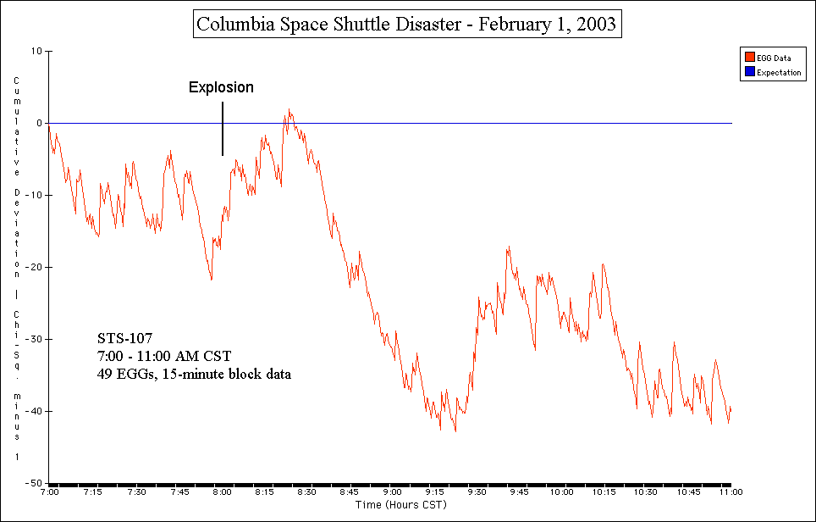

Figure 1. Resulting cumulative deviation of Chi-square graph for the formal prediction period, in 15-minute block resolution.

Since the Columbia disaster was largely a U. S.-centered event, an examination of the behavior of the EGGs located within the U. S. was also carried out. Figure 2 shows the result, with again a negative trend that becomes especially strong in the moments following the explosion, which suggests that the network trend was highly data-driven by the U. S. EGGs. The overall result was χ² = 315.41 on 336 df, p = .784.

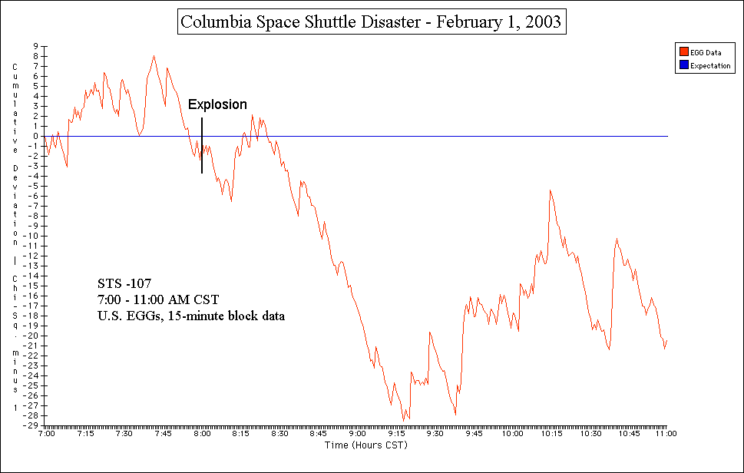

Figure 2. Resulting cumulative deviation of Ch-square graph for formal prediction period in 15-minute block resolution, using the U.S. EGGs only.

In addition, since the Columbia explosion occurred largely in the skies over north-central Texas and Louisiana, the data from the two EGGs running in Texas (EGG 103 in Austin [a dial-and-drop EGG that reported late] and EGG 2002 in San Antonio) were examined together as a means of detecting a more localized response, and Figure 3 shows the result, which is similar to the formal prediction result (Nelson et al., 2003), and is nonsignificant at χ² = 34.99 on 34 df, p = .42. A rather sharply increasing positive trend is visible prior to the explosion, and negative trend similar to those found in Figures 1 and 2 follows it.

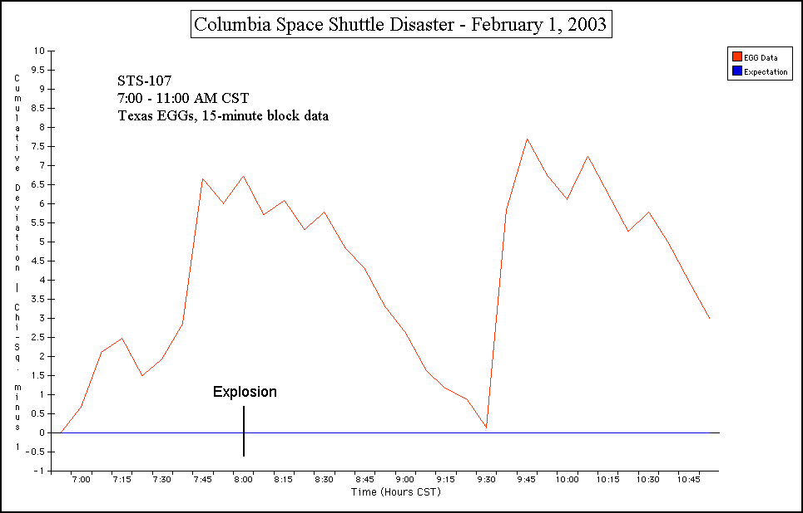

Figure 3. Resulting cumulative deviation of Chi-square graph for formal prediction period in 15-minute resolution, using the Texas EGGs only (EGGs 103 & 2002).

Figure 4 shows the larger context of the entire CST day of February 1, with the times of the explosion and the moment that President Bush addressed the nation about the loss of the Columbia at around 1:00 P.M. CST marked. The graph shows that the trend was showing chance fluctuations early in the morning up until around 2:30 A.M., at which time the trend became sharply positive for nearly four hours prior to the explosion before it began rather sharply decreasing again back towards baseline as the time of the explosion neared. The result for the full day was found to be nonsignificant overall, however (χ² = 4773.59, 4677 df, p = .159), and is a direction that is opposite to what was found in the full day graph in the formal prediction analysis (Nelson et al., 2003).

Figure 4. Context cumulative deviation of Chi-square graph for February 1, 2003, in 15-minute block resolution. Note the strong positive trend in the early morning hours.

Figure 5 shows the observed early morning positive deviation from randomness in more detail. Had this been a formal prediction, the finding would have attained significance (χ² = 1398.85, 1309 df, p = .042). An examination of the full day graph in the formal prediction analysis (Nelson et al., 2003) reveals a similar positive trend around this time, although it does not appear to be as strong as the one observed here in blocked form.

Figure 5. Graph of the strong early morning trend seen in Figure 4 shown in greater detail. The first few hours show a random walk, leading into a strong trend at around 2:30 A.M. CST.

The result for the additional exploratory analysis for the Columbia memorial ceremony can be seen in Figure 6, with the approximate times of the notable individual events during the ceremony marked for context. The graph, also created using the same Chi-square method, reveals that there was mostly a random walk throughout the hour-long ceremony, with a sharply increasing, then decreasing trend in the hour following it. The overall finding for the event is nonsignificant, with χ² = 404.16 on 392 df, p = .33.

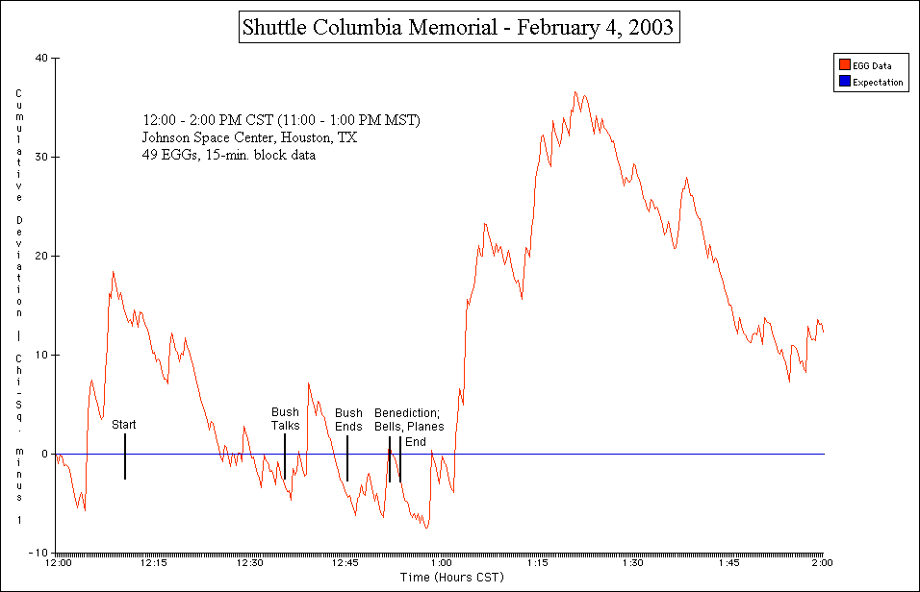

Figure 6. Resulting graph for additional exploratory analysis for Columbia memorial based on informal prediction period, with approximate times of events marked for context.

Block Odds Ratio

The range of 15-minute block Stouffer’s Z-scores for the entire CST day of February 1 can be found in Figure 7. All of the values between +2 and -2 are likely to be due to noise, but any values outside these bounds are potentially interesting. The figure indicates that about 4 values exceeded these bounds for that day.

Figure 7. Resulting 15-minute Stouffer’s Z for February 1, 2003.

Figure 8 shows the odds against chance associated with these block Z-scores. It can be seen that the values with the highest odds against chance occurred primarily in the evening, which probably the time by which most Americans were now fully aware of the tragedy and responding to it.

Figure 8. Associated two-tailed odds against chance for observed Z-scores in Figure 7.

Inter-EGG correlation

The results of the inter-EGG correlation analysis can be summarized here as z-scores and their associated probability values. For the event day of February 1, it was found that the number of positive correlations (i.e., “hits,” or r > r₀) was less than that expected by chance, but not significantly so (z = -0.44, p = .329). For the control day of January 15, the opposite of this was found, but again this was not a significant finding (z = 1.09, p = .137). Thus, the inter-EGG correlation approach had produced a null result for this event.

Discussion

The results of the analyses on the data recorded by the EGG network on February 1, 2003, when converted into 15-minute block form, seem to point toward an overall finding that conceptually replicates the one found in the formal GCP prediction analysis: the EGGs do not appear to have significantly responded to the Columbia Space Shuttle disaster. Similar to the formal prediction result in seconds resolution, the 15-minute resolution cumulative deviation of Chi-square for the formal prediction timeperiod revealed a negative directional trend that was also nonsignificant. The results for the EGGs located in the U. S. and those in Texas also show negative and baseline trends that are nonsignificant, which compliment the above result.
Perhaps the most valuable results to come out of the analyses are the stronger trends surrounding the explosion, a strong positive trend preceding the event, and a strong negative trend that follows it. The positive trend is similar to that seen in the early morning hours of September 11, 2001 (Nelson et al., 2002), and is suggestive of some kind of “pre-response” by the network. However, it is unclear just how this finding should be interpreted, as it stands as a primary example at the heart of the signal vs. artifact issue in blocking. In terms of a genuine signal, the finding could show the valuable result of blocking the data, in that it may strengthen initially weak signals in the data and allow them to be displayed more clearly, especially in the case where the signals may be spread out over a longer period of time, and are therefore barely detectable above the noise. Proposed global consciousness effects, much like intentional mind-matter interaction effects, seem to be very faint signals in most cases, and thus it may take a huge number of trials in order to have the statistical power to detect their subtle traces. Blocking would effectively increase this power by combining many trials over a set time period, and thus the chances of detecting a signal would be increased. However, in terms of a statistical artifact, we also run the risk of detecting a potentially false signal that was created through data manipulation. The inherent behavior of random data allows for some strong fluctuations that are expected to occur somewhere down the line by chance, and blocking may only inflate them, leading to a Type I error. This is even more likely to occur in the case of “data fiddling” (e.g., where one might vary the segment size being blocked to fit the fluctuations so that they are purposely larger than they really are) and not as much so in blocking over set intervals of time, but it is possible that one might come across an inflated finding by chance alone in the latter case. Thus, it is not clear on what should be made of the positive trend observed here, as there is no clear way to determine either way whether it is a true signal revealed by blocking that was too weak and spread out through time to be detectable in seconds resolution, or whether it is a random statistical artifact. The same issue holds for the strong positive trend observed following the Columbia memorial.
The negative trend also holds the same degree of ambiguity, but given that it falls short of significance, the empirical interpretation tends to point more towards chance fluctuation. From a subjective post hoc perspective, however, it is perhaps interesting to note that the negative trend, also seen in the formal GCP prediction analysis, is similar to that seen in the aftermath period of other related GCP events. The “earth consciousness” perspective of the Kennedy plane crash (Nelson, 1999b) also displayed a negative trend following the event, as did the Concorde crash (Nelson et al., 2000a) and the AA 587 crash (Nelson et al., 2001). This alone cannot be evidential within itself that the EGGs responded, but it seems to be in line with the emotion-deviation issue in that it displays a corresponding downward trend with an event that drew out feelings of sorrow and grief among many, which could be related to the anxious crying-negative deviation correlation reported by Blasband (2000). Such a trend should be studied further if it continues to appear in future GCP events. Future hypotheses to be explored here should be to see whether the direction of the deviation continues to correlate with the emotional response of the event (e.g., a positive deviation with joyous, exciting events, and a negative deviation with solemn, tragic events), and make predictions for other events accordingly in the efforts to determine what kinds of events will what specific kind of deviation.
The block odds ratio method had indicated the presence of a few interesting z-scores with high odds against chance in the evening of February 1, which is promising but is again ambiguous because random data allow for a small number of excessive values by chance alone, and thus it is not clear how many of these values are actually due to chance fluctuations. As noted, it is interesting that these values occur at times in which most Americans were fully aware of the tragedy and were responding to the news coverage on it, which would be in line with the emotion-deviation correlation, but due to the ambiguity, it does not stand as direct support of it. The finding does show that the method can be useful, and should be applied in future GCP events as an additional means of exploration.
The null result for the inter-EGG correlation approach, however, is disappointing. One possible reason for the result is that the approach did not carry the statistical power to detect any sign of the effect. Mast (2001), in his preliminary intercorrelation analyses, noted that even after 75 million trials, the effect for 1999 was still smaller than one would hope. Having only used a single day’s data, it is possible that the number of trials used was far from sufficient. Another reason, based on the findings from the other analyses reported here, could be that there was simply no correlated response for this particular event, despite its tragic nature and the gripping effect it had on people. It would seem that only further tests with the approach as it was applied here can determine whether or not it will turn out to be fruitful.

Conclusion

The results of the exploratory block analysis reported here seem to be consistent with the formal GCP prediction analysis: the EGG network does not appear to have significantly responded to the Columbia Space Shuttle disaster and its aftermath. However, the results address two issues that deserve further study in future exploratory analyses of GCP data: the issue of genuine signal vs. statistical artifact, and the possible correlation between the emotional aspects of the event and directional deviations from standard randomness. Further block explorations must also be carried out in order to further determine how signal detection increases or decreases with varying segment size; some evidence was found here that begins to suggest that it can improve slightly. Carrying out such explorations in the future as a supplement to formal GCP prediction analyses can be useful in aiding the “process-oriented” aspect of the project in determining possible ways to distinguish signal from noise, and determining the form of the randomness deviation signals that are being sought.

Acknowledgments

I wish to thank Roger Nelson of the Global Consciousness Project and the Princeton Engineering Anomalies Research Laboratory for his technical assistance and input during the course of this study.
References

Aron, A., & Aron, E. N. (1997). Statistics for the Behavioral and Social Sciences. Upper Saddle River, NJ: Prentice-Hall.
Blasband, R. A. (2000). The ordering of random events by emotional expression. Journal of Scientific Exploration 14(2), Summer. pp. 195 - 216.
Jahn, R. G., Dunne, B. J., Nelson, R. D., Dobyns, Y. H., & Bradish, G. J. (1997). Correlations of random binary sequences with pre-stated operator intention: A review of a 12-year program. Journal of Scientific Exploration 11(3), Autumn. pp. 345 - 367.
Mast, D. (2001). Inter-egg correlation of chi-squares for one-minute blocks. Available over the Internet at: http://noosphere.princeton.edu/corr.html. Downloaded March 2002.
Nelson, R. D. (1999a). Bombing in Yugoslavia: Block size comparisons. Global Consciousness Project exploratory analysis, March. Available over the Internet at: http://noosphere.princeton.edu/ results2_kosovo.html. Downloaded November 12, 2001.
Nelson, R. D. (1999b). Kennedy tragedy. Global Consciousness Project formal analysis, July. Available over the Internet at: http://noosphere.princeton.edu/results_kennedy.html. Downloaded August 26, 2002.
Nelson, R. D. (2001). Correlation of global events with REG data: An Internet-based, nonlocal anomalies experiment. Journal of Parapsychology 65(3), September. pp. 247 - 271.
Nelson, R. D. (2002). Wellstone plane crash. Global Consciousness Project formal analysis, October. Available over the Internet at: http://noosphere.princeton.edu/wellstone.html. Downloaded November 1, 2002.
Nelson, R. D., et al. (2000a). Concorde Crash, July 25 2000. Global Consciousness Project formal analysis, July. Available over the Internet at: http://noosphere.princeton.edu/concorde.html. Downloaded February 3, 2003.
Nelson, R. D., et al. (2000b). The Kursk tragedy. Global Consciousness Project formal analysis, August. Available over the Internet at: http://noosphere.princeton.edu/kursk.html. Downloaded October 14, 2002.
Nelson, R. D., et al. (2001). AA 587 crash, Nov 12, 2001. Global Consciousness Project formal analysis, November. Available over the Internet at: http://noosphere.princeton.edu/crash587. html. Downloaded December 19, 2001.
Nelson, R. D., et al. (2003). Shuttle Columbia disaster. Global Consciousness Project formal analysis, February. Available over the Internet at: http://noosphere.princeton.edu/columbia.html. Downloaded February 3, 2003.
Nelson, R. D., Boesch, H., Boller, E., Dobyns, Y., Houtkooper, J., Lettieri, A., Radin, D., Russek, L., Schwartz, G., & Wesch, J. (1998a). Global resonance of consciousness: Princess Diana and Mother Teresa. e-JAP: Electronic Journal of Anomalous Phenomena 98.1. Available over the Internet at: http://www.psy.uva.nl/eJAP. Downloaded March 1999.
Nelson, R. D., Bradish, G. J., Dobyns, Y. H., Dunne, B. J., & Jahn, R. G. (1996). FieldREG anomalies in group situations. Journal of Scientific Exploration 10(1), Spring. pp. 111 - 141.
Nelson, R. D., Jahn, R. G., Dunne, B. J., Dobyns, Y. H., & Bradish, G. J. (1998b). FieldREG II: Consciousness field effects: Replications and explorations. Journal of Scientific Exploration 12(3), Autumn. pp. 425 - 454.
Nelson, R. D., Radin, D. I., Shoup, R., & Bancel, P. A. (2002). Correlations of continuous random data with major world events. Foundations of Physics Letters 15(6), December. pp. 537 - 550.
Radin, D. I. (1997). The Conscious Universe: The Scientific Truth of Psychic Phenomena. San Francisco: HarperEdge.
Williams, B. J. (2002). Jennifer Sandy: Can the global RNG/EGG network reflect a personal loss? Global Consciousness Project exploratory analysis, September 3. Available over the Internet at: http://www.unm.edu/~asnjoe/jsandy.html.

See the GCP website: http://noosphere.princeton.edu

