Coherent Consciousness and Reduced Randomness:
Correlations on September 11, 2001

Roger D. Nelson*

Director, Global Consciousness Project, Princeton, New Jersey

Abstract
The Global Consciousness Project (GCP) is an international collaboration of researchers studying interactions of consciousness with the environment. The GCP maintains a network of random event generators (REGs) located in some 40 host sites around the world. These devices generate random data continuously and send it for archiving to a dedicated server in Princeton, New Jersey. The data are analyzed to determine whether the fundamentally unpredictable array of values contains periods of detectable non-random structure that may be correlated with global events. In this paper we examine the data from September 11, 2001, for evidence of an anomalous interaction driving the REGs to non-random behavior. Three formal analyses were made, testing hypotheses based on standardized procedures for making predictions and performing a statistical evaluation. A number of secondary analyses, including work by five independent analysts, provide additional perspective, and examine the context of several days before and after the major events. The results indicate that a substantial increase in structure was correlated with the most intense and widely shared periods of emotional reactions to the events. The non-random behavior cannot be attributed to ordinary sources such as electrical disturbances or high cell phone volume. Thus the anomalous structure is somehow related to the unusually coherent focus of human attention on these extraordinary events.

Introduction
A glimpse of the extraordinary span of human consciousness may have come from the horrific events of September 11, 2001. As we all know, beginning at about 8:45 in the morning, a series of terrorist attacks destroyed the twin towers of the World Trade Center (WTC) and severely damaged the Pentagon. Commercial airliners were hijacked and flown directly into the three buildings. The first crashed into the North tower at 8:45 and about 18 minutes later the second airliner hit the South tower. At about 9:40, a third airliner crashed into the Pentagon. A fourth hijacked plane crashed in Pennsylvania, apparently due to the heroic self-sacrifice of the passengers. At about 9:58, the South WTC tower collapsed, followed by the North tower at 10:28.

Thanks to CNN, BBC and other media, human beings all over the planet were simultaneously feeling horror, shock, fear, dismay and fascination with the same images and sounds. We were forged by the events into a collective consciousness tuned to a single frequency. In apparent correspondence, over the course of this tragic day, a world-spanning network of electronic devices exhibited unmistakable patterns where there should have been none.

Without question, these events and the powerful reactions around the world qualified as a “global event”. As such, this was an obvious case study for the Global Consciousness Project (GCP), an international collaboration involving researchers from several institutions and countries, set up to explore whether objective measurement might reveal correlations between inferred special states of consciousness on a global scale and the behavior of physical devices.

The project builds on experiments conducted over the past 35 years at a number of laboratories, demonstrating that human consciousness can interact with true random event generators (REGs), to somehow induce non-random patterns that are correlated with intentional, mental efforts (Radin and Nelson, 1989). For example, small changes in the proportion of 1s and 0s are associated with participants’ attempts to change the distribution of numbers produced by a true random event generator in controlled experiments. The results show a tiny but significant correlation with the participants’ assigned intentions (Jahn et al., 1997). The replicated demonstrations of anomalous mind/machine interactions clearly show that a broader examination of this phenomenon is warranted, and the research continues in a number of laboratories.

Variations on the theme include “FieldREG” studies that take the REG device into the field to see whether group interactions might affect the random data (Nelson et al., 1996, 1998a). In related work, prior to the Global Consciousness Project, an array of REG devices in Europe and the U.S.A. showed non-random activity during widely shared experiences of deeply engaging events. For example, the funeral ceremonies for Princess Diana created shared emotions and a coherence of consciousness that appeared to be correlated with structure in the otherwise random data (Nelson et al., 1998b). Instead of the expected, unpredictable sequence of random numbers, small changes in the mean value indicated that something had introduced a non-random element that structured the sequence, making it slightly more predictable. In graphical terms, instead of a random walk (a “drunkard’s” walk), the data sequence showed a steady trend.

These experiments were prototypes for the Global Consciousness Project. In the fully developed project, a world-spanning network of some 40 devices collect data continuously and send it to a central server in Princeton, New Jersey, via the Internet. The system is designed to create a continuous record of nominally random data over months and years, gathered from a wide distribution of locations. Its purpose is to document and display any subtle effects of humanity’s collective consciousness as we react simultaneously to global events. Our research hypothesis predicts the appearance of increasing coherence and structure, or non-random trends, in the globally distributed data collected during major events in the world. The events that comprise the sample of test cases share a common feature, namely, that they powerfully engage human attention all around the world, and draw us in large numbers into a common focus.

I take responsibility for the descriptions in this paper, but I will use collective pronouns to represent the collaborative nature of this work. I also want to acknowledge the fact that some of the terminology and images in these descriptions are convenient metaphors rather than scientific entities. I like the notion of a noosphere (Teilhard de Chardin, 1959), but it is clear that at this point the idea remains an aesthetic speculation. We do not have solid grounds to claim that the statistics and graphs demonstrate the existence of a global consciousness. On the other hand, we do have strong evidence of anomalous structure in what should be random data, and clear correspondence of these unexplained departures from expectation with well-defined events that are of special importance to people.

Method
Because this is an unusual and relatively complex experiment, the research methodology requires a brief introduction. The GCP Web site and prior publications present greater depth of description and discussion (Nelson, 1998c, 2001a). In a nutshell, the method is to collect continuous, concurrent streams of data from electronic devices designed to produce completely unpredictable and unstructured sequences of numbers. We identify events that powerfully stimulate shared human reactions, and look at the temporally corresponding data to determine whether there are significant changes from the expected random quality. The following sections document the procedures in some detail.

Data acquisition
We begin with a description of the physical data-acquisition system, and a definition of terms used for the specialized equipment. At each of a growing number (about 40 in late 2001) of host sites around the world, a well-qualified source of random bits (REG or RNG)* is attached to a computer running custom software to collect data continuously at the rate of one 200-bit trial per second. This local system is referred to as an “egg,” and the whole network has been dubbed the “EGG,” standing for “electrogaiagram,” because its design is reminiscent of an EEG for the Earth. (Of course this is just an evocative name; we are recording statistical parameters, not electrical measures.) The egg software regularly sends time-stamped, checksum-qualified data packets (each containing 5 min of data) to a server in Princeton. We access official timeservers to synchronize all the eggs to the second, to optimize the detection of inter-egg correlations. Occasional drifts occur, but any mis-synchronization is expected to have a conservative influence in our standard analyses. The server runs a program called the “basket” to manage the archival storage of the data. Other programs on the server monitor the status of the network and do automatic analytical processing of the data. These programs and processing scripts are used to create up-to-date pages on the GCP Web site, providing public access to the complete history of the project’s results. The raw data are also made available for download by those interested in checking our analyses or conducting their own assessments of the data. Each day’s data are stored in a single file with a header that provides complete identifying information, followed by the trial outcomes (sums of 200 bits) for each egg and each second. With 40 eggs running, there are well over 3 million trials generated each day.

Analysis
The database is a continuously growing matrix of trials, each of which has an expected mean of 100 and expected standard deviation of 7.071. Deviations from the expected mean can be converted directly to normally distributed Z-scores. For N eggs in the network, the Z-scores can be combined across eggs using the Stouffer method (Z_{s} = Σ Z_{i} / √N) to form a new Z-score representing the composite deviation of the mean at any given moment. This is an algebraic sum that becomes large when the eggs show correlated deviations. The Stouffer Z is the elementary unit in the standard analysis of data generated during the event of interest. If desired, the same procedures can be applied to blocked data created by taking the mean over a block of time for each egg.

The hypothesis for REG experiments in general, and for the EGG project in particular, is that the mean value of the nominally random numbers will be shifted. In other words, the output of the REG device will not be random as expected but will show a bias that is correlated with the putative source of influence. In some experiments (in the laboratory), an intention is assigned to shift the mean high or low, but in field experiments, including the GCP, there is no specified intention. Therefore, a significant deviation of the mean in either direction away from what is expected qualifies as anomalous and interesting. The standard analytical procedure looks at deviations of squared Stouffer Z-scores, which are χ² distributed, and specifies a positive accumulation. We declare an expectation that the eggs’ output will tend to show increased deviations from expectation, and test this by a one-tailed χ² accumulation. The formal hypothesis for each global event is defined in a prediction registry and specifies the period of time, the resolution (usually seconds, sometimes blocks of 1 min or 15 min), a confidence level, and any special requirements, e.g., signal averaging across time zones. The standard analysis described here is used unless another procedure is defined in advance for the registered prediction.

The important qualities of the standard analysis are: (a) All the procedures are well understood and widely used in statistics, (b) normalization is straightforward and based on a well-characterized mean and standard deviation,* (c) χ² values are additive, so the results from separate eggs or minutes or occasions can easily be combined to give an overall picture, and (d) the analysis represents the basic idea that the eggs will exhibit a degree of correlated behavior if they somehow respond to events in the world.

The primary focus of the GCP analysis thus is on tests for anomalous shifts of the mean during periods of time specified in formal predictions. This addresses the question whether there is a tendency for the eggs to reveal increased, correlated deviation from expectation during the specified times. In other words, it tests whether there is unusual consistency in the behavior of the eggs moment by moment over the period of interest.

Predictions
The tests for the overall GCP hypothesis depend on a Prediction Registry to establish the timing and analysis parameters for each event. This time-stamped registry is available for public inspection on the GCP Web site. Because we often cannot identify relevant events before their occurrence, we use categorical specifications to help select a reasonable sample of cases to represent the hypothesis. On the basis of prior experience, we postulate broadly engaging, emotionally salient events and situations as the conditions that we expect will be correlated with anomalous and significant deviations in the REG data-streams. We set the criteria for global events restrictively, to identify very few occasions with broad scope and impact for a large number of people around the world. Each prediction identifies the period of time during which a deviation is expected in the data, and it provides the information needed for analysis. It may be helpful to note that each formal prediction is in some sense a new “experiment,” so that the full database may be thought of as a large number of replications of a simple experiment.

There are three distinct categories for predictions. In some cases, they address known events, such as New Year’s Eve celebrations and other widely observed holidays, and certain globally interesting scheduled events, such as World Cup Soccer and the Olympics. Also known ahead of time, but with no regular schedule or repetition, are widely publicized ceremonies such as the Princess Diana and Mother Teresa funerals. In this category we also may place unusual cosmic events, such as full solar eclipses. Finally, there is a large category of unpredictable events that gather worldwide attention, such as major earthquakes, the fall of the Berlin wall, the assassination of Israeli Prime Minister Rabin, the detonation of atomic weapons in India and Pakistan, or the terrorist attacks of September 11, 2001. The times we use for archiving the data, and hence for the predictions and analyses, are registered unambiguously in coordinated universal time (UTC or GMT).

A prime source of predictions is inevitably the international news services such as CNN and BBC. The reports of a major story identify its scope and usually provide enough information to specify the timing. Relatively local events also may be considered for predictions if they involve powerful engagement of many people in some part of the world. Obviously, we cannot discover or assess all possible global events, so the selection is arbitrary and constitutes a fixed sample from an indefinitely large population. A prediction may have two aspects, one referring to the moments of the actual event and one that looks at growing world consciousness of the event. The first might be envisioned as representing a “psychic” reaction that might occur if there were something like an independent global consciousness or, alternatively, an immediate effect from intense local reactions. The second type represents a more ordinary conscious engagement across large numbers of people because of media coverage.

Controls
Control data are needed to establish the viability of the statistical results. Because predictions for the GCP are situation dependent, we need specially designed procedures to ensure that the statistical characterizations of the complex array of data are valid. There are several components in the control procedures. We begin with quality-controlled equipment design with special attention to the exclusion of electromagnetic and environmental influences. The data are further processed through a logical XOR stage that eliminates, to first order, any physically induced bias of the mean, at the cost of possible effects on higher moments of the distribution. The REGs are empirically tested by thorough device calibration based, typically, on one million trials. In addition, resampling procedures are used to examine the distribution of parameters in control segments from the actual data. See Nelson et al. (1998a) for more detail and examples. Finally, we conduct another type of control analysis, based on a complete clone of the GCP database with all trial values replaced by values created from a high-quality pseudo-random algorithm. Details are beyond the scope of this article, but the control analysis essentially duplicates the formal analysis using the pseudo-random database, which is expected to show only normal variations. The combined force of these efforts ensures that the GCP data meet rigorous standards and that the active subsets subjected to hypothesis testing are correctly evaluated against expectations established by theory and appropriate control and calibration data.

Results
The introduction and the description of methodology should make it clear that the tragedies of September 11, 2001, are an obvious test case, a global event that should, according to the general hypothesis, affect the EGG network. Two formal predictions were made for the major events on Sept. 11 and one for an associated event on Sept. 14. There are some less-directly associated events later, but we will focus on these three examples, plus some contextual analyses that are helpful for interpretations. The standard analysis yields an inferential statistic as described previously. The relative consistency of anomalous effects leading to that statistic can be visualized in a graph showing the progressive departure of the data from expectation, which is a random walk centered on a horizontal path at zero deviation. The data from all the eggs are combined in a single score for each second, these Z-scores are squared, and the cumulative deviation from chance expectation of the resulting sequence is plotted.

Formal: Composite Deviation of Means
The primary formal prediction for September 11 was based on that made for the terrorist bombings of U.S.A. Embassies in Africa in August 1998. It specified a period beginning an arbitrary 10 minutes before the first crash to four hours after, thus including the actual attacks plus an aftermath period of a little more than two hours following the last of the major cataclysmic events. Figure 1 is the graph of data from this formal prediction, with the times of the major events indicated by boxes on the zero line. It shows a fluctuating deviation during the moments of the five major events, as increasing numbers of people around the world were watching and hearing the news in stunned disbelief. The uncertain fluctuation of the EGG data continues for almost half an hour after the fall of the second WTC tower. Then, a little before 11:00, the cumulative deviation takes on a trend that continues through the aftermath period and ultimately exceeds the significance criterion, with a final probability of 0.028 (χ² is 15332 on 15000 degrees of freedom, with 37 eggs reporting.)
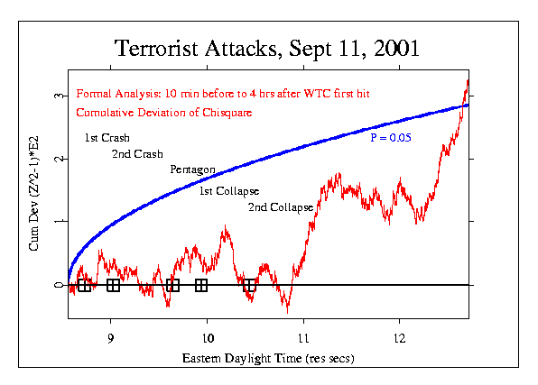
Figure 1: Cumulative deviation of χ² based on Stouffer Z across eggs for each second, from 08:35 to 12:45 EDT, September 11, 2001. The separate events of the terrorist attacks are marked with rectangles on the line of zero deviation. A smooth parabolic curve shows the locus of a 5% probability against chance.

The formal test thus indicates a significant departure from expectation, but it is not especially persuasive by itself, given the enormity of the event. Moreover, the outcome clearly is dependent on the arbitrary pre-specification of the timing in the formal hypothesis. It is therefore helpful to examine the larger context by looking at the behavior of the eggs before and after September 11. We find that while there is nothing unusual in the data from preceding days, the opposite is true following the attacks. During most of Sept. 11, 12, and 13 there is a strong trend indicating correlated behavior among the eggs. This persistent deviation from random behavior appears to begin a little before the first crash, and it continues well beyond the time specified in the formal prediction. As it happens, the predicted aftermath of a few hours could not capture what appears in context to be a much longer-lasting aberration in the normally random flow of data.
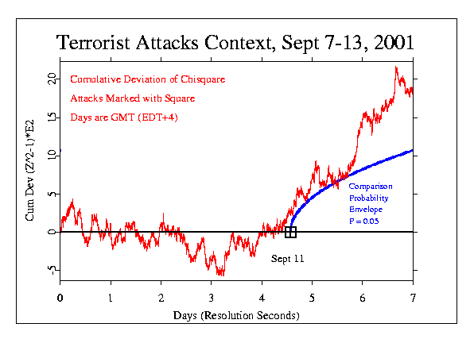
Figure 2 shows the period from September 7 through 13, with the time of the attacks on September 11 marked by a black rectangle. It is apparent that shortly before the terrorist attack, the wandering line takes on a strong trend representing a persistent departure from what is expected of random data. A small probability envelope inserted at that point provides a comparison standard to indicate the scale of the deviation. The slope of the graph beginning just before the first WTC tower was hit and continuing for over two days, to noon on the 13th, is essentially linear and it is extreme. An informal estimate of the chance probability can be made from its slope, and lies between 0.003 and 0.0003, suggesting an odds ratio on the order of 1000 to 1. If we extrapolate the anomalous trend, it begins at about 04:00 (08:00 GMT), several hours before the first World Trade Center tower was hit, and the total length of this persistent trend is about 56 hours. The mean number of days between segments with a slope like this, continuing for so long, is on the order of 2300 days, which is consistent with the 1000 to 1 odds ratio suggested by the slope itself.
Figure 2: Cumulative deviation of χ² based on Stouffer Z across eggs for each second, from Sept. 7 through Sept. 13, 2001. The time of terrorist attacks is marked with a rectangle on the line of zero deviation. A smooth parabolic curve beginning at the time of the attacks provides a 5% probability comparison.

The multi-day perspective places the formal specification in a larger context, and we also can look at finer details. Figure 3 shows the raw odds against chance, second-by-second, for the squared Stouffer Z-scores (χ²s) for September 11. The maximum odds ratio, shown as a spike in the center of the graph, is equivalent to a Z-score of 4.81, and occurs at 10:12:47, EDT, not long after the first World Trade Center tower collapsed. A Z-score this large would appear by chance only once in about a million seconds (roughly two weeks). It is not terribly unusual to find such a spike in our three-year database, but it is thought-provoking that one does occur within the brief time-span of the attacks, about an hour and 45 minutes. The ratio of this period to the mean time between spikes of this magnitude is 1/192, suggesting odds of nearly 200 to 1 for this being just a chance occurrence. The same data were smoothed by taking a one-hour moving average of the Z-scores before calculating the χ² and odds ratios. The smoothed data are shown in gray, with linear re-scaling by a factor of 10,000 to display the concentrations of excess correlation over the whole day. The largest cluster of extreme odds ratios occurs over the period from about 09:30 to 12:30.
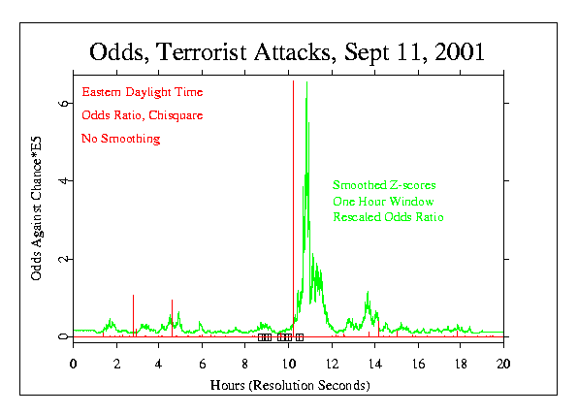
Figure 3: Odds ratios for the squared Stouffer Z across eggs for each second, on September 11, 2001. Times of the separate events in the terrorist attack are marked with rectangles on the zero line. The extreme spike occurs at 10:12:47 EDT. A smoothed and re-scaled version shows more detail (see text).

Formal: Variance of the Data
The second formal prediction addressed the variability of scores (variance) among the 37 eggs over the course of the day of September 11. It was a test of Dean Radin’s emailed hypothesis that the variance would show strong fluctuations: “I’d predict something like ripples of high and low variance, as the emotional shocks continue to reverberate for days and weeks.” Although this was only a partial specification it effectively predicted that the variance around the time of the disaster would deviate from expectation. I added the necessary specifications for a formal analysis, predicting increased variance among the individual eggs at the beginning followed by low variance after the intensely disturbing events. The intent was to specify a degree of variability in the data that might correspond to the reactions of people engaged by this uniquely powerful emotional imposition. In the event, as Figure 4 shows, the variance measure exhibits normal random fluctuation around the horizontal line of expectation until about three or four hours before the attack, and then a steep and persistent rise indicating a great excess of variance, continuing until about 11:00. Shortly thereafter, a long period begins during which the data show an equally precipitous decrease of variance.

In this figure, the X-axis shows Eastern Daylight Time, allowing a direct reading of the timing of the strong deviations. We note also that the distinctive shape of the graph is suggestive of a classic “head and shoulders” graph seen in stock market analysis of leading indicators (Walker, 2001). As in Figure 2, there is a suggestion that the effects registered for this horrendous event might have begun several hours prior to the first attack.
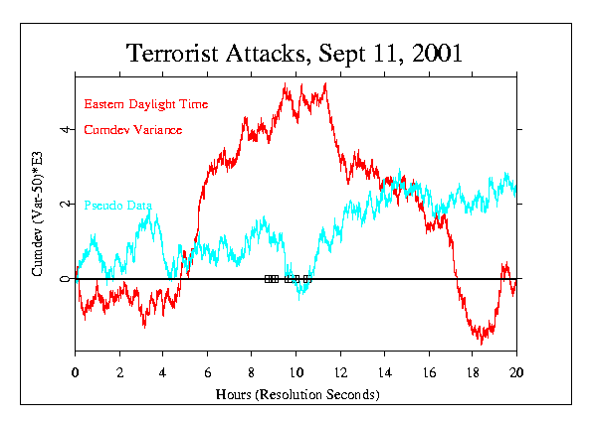
Figure 4: Cumulative deviation of variance across eggs for each second, on September 11, 2001. Times of the separate events in the terrorist attack are marked with rectangles on the zero line. The light gray curve labeled “Pseudo Data” shows a control calculation using a pseudo-random clone dataset for the day.

For a visual indication of the likelihood that the data show merely random fluctuation, a comparison can be made with the pseudo-data generated for September 11, 2001, and plotted in the same format. In contrast to the real data, there are no long-sustained periods of strong deviation in the algorithmically generated data. While it is not a rigorous test, this comparison with the pseudo-data indicates that the variance measure is unusual around the time of the attacks. It is difficult to make a direct calculation of probability for this analysis, but a conservative estimate is included in the formal database. It is based on assessing the fast rise and the fast fall of the variance measure surrounding the period of the attacks. The probability for each was calculated by extrapolation of the probability envelope as far as would be needed to achieve the extreme rise or fall by chance, compared to the much shorter envelope that covers the time of the actual rise or fall. The resulting estimate is p = 0.096. Independent analyses by Peter Bancel and Richard Shoup, described later, suggest much a smaller probability.

Formal: Silent Prayer
After September 11, innumerable calls for prayer were made. On September 14 there was a special emphasis on such collective spiritual moments, including major organized periods of silence in Europe and America. Doug Mast made a formal prediction for a deviation of the χ² over the time periods of 10:00 to 10:03 GMT, corresponding to an organized mourning in Europe, and 12:00 to 12:03 EDT (16:00 to 16:03 GMT), corresponding to the beginning of the Washington DC service and many other organized mourning events in the Eastern U.S.A. Figure 5 is the resulting graph. The picture is compelling, I think, although it does not confirm the formal prediction. Instead, the trend shows a marginally significant decrease in the deviations of the egg data. The χ² is 150.68 on 180 degrees of freedom, with probability 0.95. The trend is steadily opposite to the usual (and specified) direction, but in an aesthetic sense it looks right — symbolic of the moment’s contrast to the preceding days.
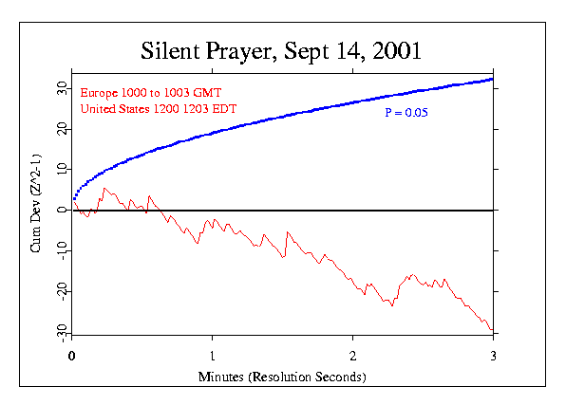
Figure 5: Cumulative deviation of χ² based on Stouffer Z across eggs for each second, for a three-minute period of silence on September 14, 2001. The plotted curve is a signal average of data from separate mourning ceremonies in Europe and Washington, DC. The smooth parabolic curve shows the locus of a 5% probability against chance.

Other formal predictions were made for events related to Sept. 11. These include the Sea to Shining Sea benefit concert on Sept. 22, the Maharishi Effect meditations during Sept. 23 to 27, the beginning of bombing in Afghanistan, Oct. 7, the Childrens’ Pledge of Allegiance, Oct. 12, and an Internet-promoted, magical Binding Spell on Bin Laden, Oct. 15. All showed modest positive deviations, with probabilities ranging from 0.29 to 0.04. Details may be found on the GCP Web site.

Exploratory Work by Independent Analysts
The formal hypothesis testing is augmented by exploratory analyses that add breadth and depth to the picture. Interpreted carefully, they help understand the data, and they can be a primary source for future analytical questions. Five people have contributed independent assessments.

Dean Radin produced a variety of analyses of the September 11 events. One sample is presented here, and more can be found on the GCP Web site and in a paper addressing the effect of location of the eggs on the size of the deviations (Radin, 2001). Dean’s treatment of the low-level data is different from the GCP’s standard approach. Instead of a composite (Stouffer) Z across eggs, he calculates the Z-score per egg and sums the squared Z-scores and degrees of freedom across eggs. This responds to the variability among the eggs, while the standard analysis responds to correlated deviation among the eggs. Dean uses sliding window smoothing or moving averages of the data across time. This can make interpretation difficult because the results depend very heavily on the choice of parameters such as the window width and centering. Because Dean generally tries several sets of parameters in exploring the data, the probabilities associated with his findings should be adjusted for multiple testing, probably by a factor of 5 to 10. Dean feels that while exploratory data analysis is an inappropriate tool for formal hypothesis testing, it is a necessary next step in attempting to understand statistical anomalies, and it often proves to be valuable in developing future hypotheses. I should add that Dean says that, unlike some of the other mass events he has examined in the GCP database, nearly every analysis he tried with respect to September 11, from one-second resolution to nearly a year's worth of surrounding data, revealed unexpected statistical structure on that day.

Figure 6 shows the 1-tailed odds ratios associated with moving average Z-scores calculated with a 6-hour sliding window for the data from Sept. 6–13. The Z-score variations show a particularly large excursion on the day of the attacks, corresponding to a peak of Z = 3.4 that then drops to Z = −3.1 over the next seven hours. A permutation analysis shows that the likelihood of finding a 6.5-sigma drop in Z-scores (based on a 6-hour sliding window) in one day and within 8 hours or less is p = 0.002. Dean identifies the major spike in this graph as occurring at about 9:30 AM, Sept. 11. However, the algorithm that he used for the sliding window averages the data for the six hours preceding the plotted point. Thus, in terms of the original, unsmoothed data, the spike incorporates some large deviations early in the morning, and the peak weight of the moving average actually centers at 06:30, somewhat more than two hours prior to the first WTC hit.

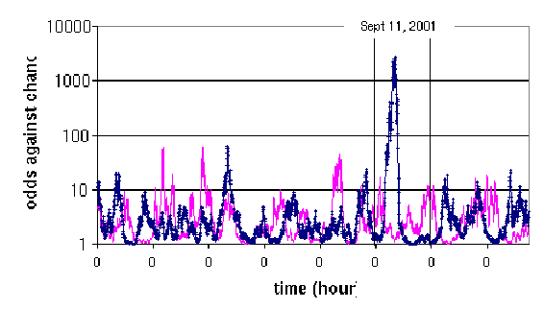
To help assure that there was no mistake in the processing, the same calculations were made using the clone database of algorithmically generated pseudo-random data. These “control” data are plotted in gray in Figure 6, and though occasional peaks occur, they show only expected random variation. None of the pseudo-random excursions approaches the magnitude of the spike on September 11.
Figure 6: Odds ratios for the moving average of Z² across eggs with a six-hour smoothing window, from Sept. 6 through 13, 2001. The Y-axis is a log scale; “0”on the X-axis marks the beginning of each day. The gray curve shows the pseudo-random clone data for Sept. 11, processed with the same algorithms. Figure by Dean Radin.

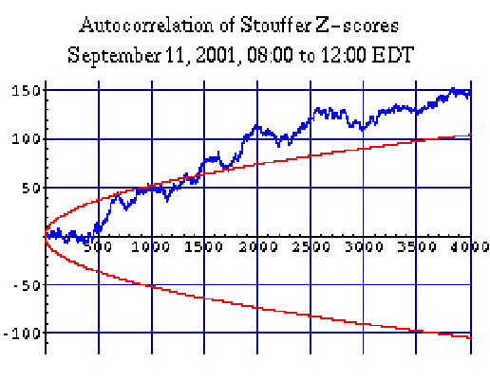
Peter Bancel has taken another perspective, focusing on the correlation of the eggs’ output over time (Bancel, 2001). He describes his procedure as an autocorrelation of the second-by-second Stouffer Zs, using Fourier techniques. The resulting coefficients are normalized as the square root of the number of data points minus the autocorrelation lag. This yields a distribution of Z values that is expected to be very close to the standard normal distribution. The result is visualized by taking the cumulative sum, as is done in the χ² figures. Figure 7 shows the four-hour period from 08:00 to 12:00 EDT on September 11. The large rise in the curve indicates an excess of correlation among the eggs during this time. It is evidently driven by a strong, persistent deviation in the average Z-score across eggs during the period from 9:50 to 11:50. The positive excursion of the Z-scores has a two-tailed p-value of 2  10^{–4} (z = 3.71). Placed in the context of a 24-hour data window, a reasonable Bonferroni correction yields a p-value of 2.5  10^{–3}. No other such block of data on Sept. 11 shows any noteworthy trend.

Figure 7: Cumulative sum of normalized autocorrelation coefficients for the second-by-second Stouffer Z-scores. The time period is from 08:00 to 12:00 on September 11. The smooth curves show the 90% confidence interval. Figure by Peter Bancel.

Richard Shoup also has examined correlations over time, as well as other aspects of the GCP data. He uses the same treatment of the raw data as Radin, and hence is also looking at a measure of variability among the eggs. The analyses are particularly concerned with determining whether the September 11 data really are uniquely deviant in the context of long time-spans, and he concludes that they are, based on assessing four months of data (July through October, 2001). One aspect of this effort addresses the question whether there is similar behavior across the eggs instead of the expected random relationship during the time of interest. Figure 8 is a sample from an extensive array of analyses (Shoup, 2001a). It shows the cumulative deviation of the moving average of χ²s calculated by summing the squared Z-scores per egg for each second for 32 eggs with complete data. The smoothing window in this case is one hour, and uses data from the past relative to the plotted point. The X-axis shows time in UTC, which was four hours later than New York time on September 11. This analysis assesses the generality of the large correlated increase in variance beginning around 8:00 UTC, by dividing the eggs into two groups in several different ways and plotting a separate curve for each group. The curves all show the same pattern, indicating strong correlation beginning at about 4:00 or 5:00 EDT and continuing for the entire day. Shoup establishes that no such correlations are seen in arbitrarily selected “control” days.
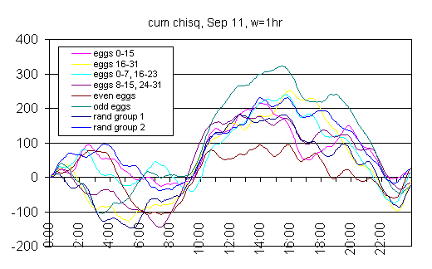
Figure 8: Cumulative deviation of the moving average of χ²s calculated by summing the squared Z-scores per egg for each second, using a smoothing window of one hour. Separate curves show several pair-wise comparisons of subgroups of the eggs to give a visual impression of their correlated anomalous deviation. Figure by Richard Shoup.

Ed May and James Spottiswoode took a severely critical look at the Sept. 11 results (May & Spottiswoode, 2001). They began with a thorough examination of the nature of the data, and concluded that the GCP network of REGs does exactly what it is designed to do: it produces a continuing swath of random data, indistinguishable from theoretical expectation. They then selected certain of the formal and exploratory analyses to see whether they could find any way to discount them. They determined that their analysis of the primary formal hypothesis test confirmed the GCP analysis, but went on to say that its hypothesis formulation was unclear, that the specified time was fortuitous, and that the result was not very impressive, given the magnitude of the global event. For the exploratory analysis, they focused on Dean Radin’s sliding window approach and demonstrated that, as noted earlier, the result is dependent on the size of the window. They showed that apparently strong spikes can be made to disappear, or to appear, by judicious selection of the parameters.

Comprehensive Results
Although this paper is most concerned with the events of September 11, the formal predictions and analyses related to the terrorist attacks and the aftermath are only a small part of the GCP database. It is not practical to provide details of the other analyses here, yet the September 11 results should be viewed within that context. In a sense, each individual prediction is another replication of the basic experiment, and the full database is a concatenation of the evidence for the general hypothesis. In other words, the proper test of the hypothesis that there will be structure in the EGG data correlated with noteworthy events in the world is an accumulation of evidence from a growing database of specified global events.

At the end of October 2001, 87 formal predictions had been made over a three-year period. The individual results can be cumulated over time to provide a summary of the GCP experiment as a whole. Figure 9 shows the accumulating excess of the χ²s over their corresponding degrees of freedom for the 87 analyses. It culminates in a composite probability for the whole array of events that is 2.3  10^{–7}. The dotted lines show probability envelopes for the cumulative deviation from chance expectation, which is plotted as the horizontal black line at zero deviation.
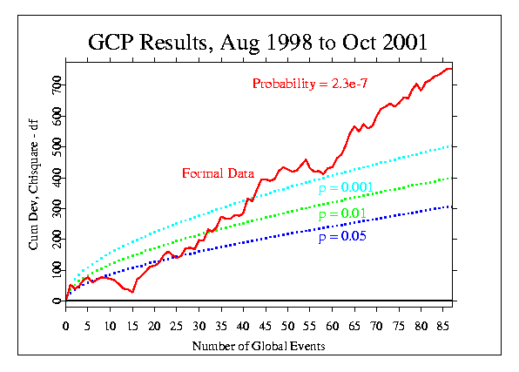
Figure 9: Overall results for 87 formal experiments over the past three years. The data curve shows the cumulative deviation from chance expectation of the individual “bottom line” χ²s for the separate events. Expectation is shown as the horizontal line at zero. Dotted curves show the 5%, 1%, and 0.1% confidence levels.

As is the case with any experiment using statistical measures, there is considerable variation in the results, but about two-thirds of the cases have a positive deviation, and 21% are independently significant at or beyond the 5% level. The composite probability that chance fluctuation can account for the total deviation from expectation is less than one in a million. Tables and graphical displays on the GCP Web site give up-to-date summaries of the formal results (Nelson, 1998c). Most of the table entries contain a link to a complete description of the detailed analysis for the event, and in many cases, further explorations and investigations that provide illuminating context for the formal prediction.

Discussion
The accumulating evidence for an anomalous effect on the Global Consciousness Project’s network of REG devices placed around the world is strong. Multiple, independent analyses show unmistakable structure in data that should be genuinely random. There is a small but highly significant statistical deviation from theoretical expectation for the REG outputs, integrated across all the active devices, and it is correlated with global events identified by experimenters without knowledge of the data or results. We do not have a theoretical understanding of the sort that must underlie robust interpretations, but several potential explanations for the results may be considered.

Perhaps the first proposals that come to mind are spurious physical effects that arise directly out of the extreme conditions of a day like September 11. For example, since the eggs are electronic devices, perhaps some combination of extraordinary stresses on the power grid, or unusual electromagnetic fields, or huge increases in cell phone usage might have altered the REG outputs. Such influences would center on New York and Washington, of course, while the eggs are distributed around the world. Their average distance from New York is more than 4000 miles (~6400 Km). More importantly, the design of the research-grade instruments includes both physical shielding and a logic stage that literally excludes first-order biasing from electromagnetic or other physical causes. Thus we are forced to look elsewhere for the source of the induced structure.

The patterning is statistical in nature (a small, correlated mean shift) and is similar to what is seen in laboratory research and in field applications of the REG technology. Indeed, this similarity raises the question why the effects are not stronger, given the large number of REG devices and the very large numbers of people who may be regarded as sources. In fact, there is no substantial evidence to support the assumption that multiple REGs will necessarily yield a compounded effect, or that multiple ostensible sources will increase effect sizes. For example, when larger effect sizes for pairs of participants have been reported, the attribution is not to the number of people but to the quality of the relationship (Dunne, 1993), and in the FieldREG studies there is no correlation of group size and effect size. The same general principle may apply to the data reported here. The effects appear to be dependent on the nature of the situation, including obviously subjective aspects, and not on simple physical parameters such as the location of detectors relative to the focus of a correlated event, the number of detectors, or the number of people involved. On the other hand, a preliminary analysis of the Sept. 11 data suggests there may be an effect of geographic location (Radin, 2001). The potential for serious, objective assessment of questions like these is enormous, given the continuous and growing database, the wide distribution of the REG network, and the unending variety of potentially instructive events.

A particularly thought-provoking aspect of the anomalous changes in the data is that they appear to begin before the major events. Because our measures are statistical and necessarily have an error distribution around the trends and point estimates, these indications must be regarded with caution. They are present, however, in multiple analytical perspectives, and we should consider some provisional interpretations. The major trends began to appear on the order of two to four hours prior to the first crash. Certainly no ordinary physical source such as electromagnetic disturbances would seem to be a candidate. If ordinary waking consciousness were the source, it would seem it could only be attributable to a small number of people: the terrorists who knew what was coming. Alternatively, the hypothesized global consciousness that later would be intensely aware might have had a premonitory cognition or feeling at an unconscious level that was registered in the data from the EGG network. There are a number of laboratory studies that document an analogous “precursor” response in humans about to be presented with a shocking stimulus (Bierman & Radin, 2000).

In any case, the formal data from the EGG network definitely show anomalous deviations that are consonant with our general hypothesis. Many of the individual events have results that, in addition to their statistical contribution, also exhibit temporal patterns that are subjectively striking, perhaps even meaningful. Indeed, when we look for further insight from subjective or aesthetic perspectives to complement the hard-edged, scientific analyses, there are a plethora of indicators that seem meaningful. Discussion of these is beyond the scope of this article, but many examples from contextual and exploratory studies are discussed in a special section of the GCP Web site (Nelson, 2001b). Of course we try hard to understand what the data say, and, having looked long and carefully at the subtle patterns, we can attempt explanations in a rudimentary form. It is obviously important to identify the attempts as speculative and provisional, but having said that, I would like to describe a picture that appeals to me aesthetically. You can find more general discussion of alternatives and cautions on the GCP Web site.

One way to think of these unexpected correlations is to consider the possibility that the instruments actually have captured the reaction of an inchoate global consciousness. The network was built to do just that: to see whether we could gather evidence for effects of a communal, shared mind in which we are participants even if we don’t know it. Groups of people, including the group that is the whole world, have a place in consciousness space, and under special circumstances they — or we — become a stronger presence. Based on experimental evidence that both individuals and groups manifest something suggestive of a consciousness field, the GCP grew out of the hypothesis that there could be a global consciousness capable of the same thing. Pursuing this speculation, we could envision an integrated global mind that pays consistent attention to events that inspire strong coherence of attention and feeling among its constituents. Perhaps a useful image is an infant just beginning to develop an integrated awareness, but already manifesting recognizable emotions in response to the enveloping comfort of cuddling or the intense discomfort of pain.

The hypothesis we set out to test is that the REG devices we use may respond to the concerted effect of large numbers of people turning their attention in one direction, becoming deeply absorbed in one focus. There are alternatives to such an explanation of the deviations as an effect of communal consciousness, including that the experimenters themselves might be the source of anomalous effects. This is a viable hypothesis according to professional parapsychologists (White, 1976), and we can accept the possibility that such an “experimenter effect” may contribute to the overall result. The characteristics of the individual events and their correlated outcomes, however, suggest that a broader and more comprehensive source is a major contributor. In the full database of formal and exploratory analyses, there are several instructive parallel cases. For example, my expectation, and that of my colleagues, for the Omagh bombing event in Northern Ireland was exactly the same as for the embassy bombings in Africa. They both were egregious travesties, and they both were the most prominent international news items when they occurred. Yet, the results for these two analyses are completely different; one showed a huge effect, the other none at all. The tragedy in Nicaragua in October 1998 from flooding and the collapse of the Casitas volcano showed no response, contrary to our expectations. The bombing in Iraq produced no response, while that in Yugoslavia yielded a highly significant deviation. New Year’s Eve, which clearly meets the criteria for global interest as well as the experimenters’ expectations, appears to produce quite different results each year, but in the three New Years we have assessed, the data around midnight are nonetheless unmistakably structured, not random.

Either of these models — communal consciousness or experimenter effect — begs for an interaction mechanism. One suggestion is to co-opt the essential qualities of field theory for a “consciousness field” that carries information (Nelson, 1999). This is not completely out of touch with models in physics, and might be formalized in terms of David Bohm’s concept of “active information” (Bohm, 1980). Other efforts to describe a mechanism that could produce the anomalous results in these experiments draw on the “observer” requirements of quantum theory. The idea is that future observation collapses a superposition of possibilities into a state that may represent reality (Schmidt, 1982; Walker, 2000). A recent formalization of this approach argues that no major changes to physical theory are required to address anomalous effects of consciousness (Shoup, 2001b).

The terrible events of September 11 were a powerful magnet for our shared attention. More than any event in recent memory, they evoked extraordinary emotions of horror, fear, commiseration and dismay. The EGG network reacted in a powerful and evocative way. While there are viable alternative explanations, the anomalous correlation is not a mistake or a misreading. It can be interpreted as a clear, if indirect, confirmation of the hypothesis that the eggs’ behavior is affected by global events and our reactions to them. This is startling in scientific terms because we do not have widely accepted models that accommodate such an interpretation of the data. More important than the scientific interpretation, however, may be the question of meaning. What shall we learn, and what should we do in the face of compelling evidence that we may be part of a global consciousness? Of course, this is not a new idea or a novel question. The results from this scientific study are an apparent manifestation of the ancient idea that we are all interconnected, and that what we think and feel has effects everywhere in the world. The discovery of patterns in the GCP data that appear to reflect our shock and dismay implies that these insensate but labile electronic random generators can “see” the effect of massive, shared emotion and attention. The challenges posed by this unexplained effect are great, but it may be an unexpected source of incisive questions about the span of human consciousness.

Conclusion
The GCP is an extension of laboratory REG experiments and non-intentional FieldREG experiments to a much larger domain, using a network of REG sampling nodes distributed around the world. The data from multiple, independent devices running in parallel, continuously over months and years, can be a rich resource for a variety of purposes, including correlation with special moments in time as described in this article. It also may be instructive to attempt correlations with other variables such as the geophysical and cosmological data that have shown some promise in psychophysiological and parapsychological research. Thus far, the main focus of the project has been on the question whether any evidence of a communal global consciousness can be seen. A definitive answer will require patient, continuing data collection combined with creative assessment techniques, but already it appears that by our simple measures there is robust evidence for part of the picture. Anomalous departures of the data from expectation are demonstrably correlated with global events that are important to human beings.

Excellent technology, sound experimental design, rigorous analysis, and sophisticated controls exclude ordinary physical and environmental variations as spurious sources. Although the effects on the GCP data may be modulated by experimenter expectations or other subjective influences, the most consistent correlate and hence the most likely source of the apparent effects is the relatively high coherence of widespread attention during events with a strong global focus. This report on the data from September 11 is the best description we can give empirical measurements and effects that are essentially mysterious. We do not know how the correlations that arise between electronic random event generators and human concerns come to be, and yet, the results of our analyses are unequivocal. The network responded as if the coherence and intensity of our common reaction created a sustained pulse of order in the random flow of numbers from our instruments. These patterns where there should be none look like reflections of our concentrated focus of attention, as the riveting events drew us from our individual concerns and melded us into an extraordinary shared state. Maybe we became, briefly, a coherent global consciousness.

Acknowledgments
The Global Consciousness Project would not exist except for the immense contributions of Greg Nelson and John Walker, who created the architecture and the sophisticated software. Paul Bethke ported the egg software to Windows, thus broadening the network. Dean Radin, Dick Bierman, Jiri Wackermann, and others in the planning group contributed ideas and experience. Rick Berger helped to create an elegant Web site to make the project available to the public. The project also would not exist but for the commitment of time, resources, and good will from all the egg hosts. Our financial support comes from individuals including Charles Overby, Tony Cohen, Reinhilde Nelson, Michael Heany, Alexander Imich, Richard Adams, Richard Wallace, and Anonymous. The Institute of Noetic Sciences provides logistical support as a non-profit home for the project, and the Lifebridge Foundation has provided generous support for documentation of the GCP. Finally, there are very many friends of the EGG project whose good will, interest, and empathy open a necessary niche in consciousness space.

References

Bancel, P. (2001). Draft Report on Autocorrelations in GCP Data of September 11, 2001. Retrieved Oct. 28, 2001, from the World Wide Web: http://noosphere.princeton.edu/bancel/interegg.corr.html

Bierman, D. J. & Radin, D. I. (2000). Anomalous unconscious emotional responses: Evidence for a reversal of the arrow of time. In S. Hameroff, A. Kaszniak, & D. Chalmers (eds.) Towards a science of consciousness III: The Third Tucson Discussions and Debates. Boston: MIT Press.

Bohm, D. (1980). Wholeness and the implicate order. Boston: Routledge & Kegan Paul.

Dunne, B. J. (1993). Co-operator experiments with an REG device. In K. R. Rao (ed.), Cultivating consciousness for enhancing human potential, wellness, and healing (pp. 149–163). Westport, CT: Praeger.

Jahn, R. G., Dunne, B. J., Nelson, R. D., Dobyns, Y. H., & Bradish, G. J. (1997). Correlations of random binary sequences with pre-stated operator intention: A review of a 12-year program. Journal of Scientific Exploration, 11, 345–367.

May, E. & Spottiswoode, J. (2001). Memorandum for the record, re: Analysis of the Global Consciousness Project’s data near the 11 September 2001 events. Retrieved Oct. 28, 2001, from the World Wide Web: http://noosphere.princeton.edu/papers/Sep1101.pdf

Nelson, R. D., Bradish, G. J., Dobyns, Y. H., Dunne, B. J., & Jahn, R. G. (1996). FieldREG anomalies in group situations. Journal of Scientific Exploration, 10, 111–141.

Nelson, R. D., Jahn, R. G., Dunne, B. J., Dobyns, Y. H., & Bradish, G. J. (1998a). FieldREG II: Consciousness field effects: Replications and explorations. Journal of Scientific Exploration, 12, 425–454.

Nelson, R., Boesch, H., Boller, E., Dobyns, Y., Houtkooper, J., Lettieri, A., Radin, D., Russek, L., Schwartz, G., & Wesch, J. (1998b). Global resonance of consciousness: Princess Diana and Mother Teresa. Electronic Journal for Anomalous Phenomena, eJAP. Retrieved Oct. 28, 2001, from the World Wide Web: http://www.psy.uva.nl/eJAP

Nelson, R. D. (1998c). The Global Consciousness Project: Registering Coherence and Resonance in the World. Retrieved Nov 24, 2001, from the World Wide Web: http://noosphere.princeton.edu

Nelson, R. D. (1999). “The Physical Basis of Intentional Healing Systems.” Technical Report PEAR 99001, Princeton Engineering Anomalies Research, Princeton University, Princeton, NJ.

Nelson, R. D. (2001a). Correlation of global events with REG data: An internet-based, nonlocal anomalies experiment. The Journal of Parapsychology, Vol. 65, September 2001 (pp. 247–271).

Nelson R. D. (2001b). Exploratory Studies: The Global Consciousness Project. Retrieved Oct. 28, 2001, from the World Wide Web: http://noosphere.princeton.edu/res.informal.html

Radin, D. I. (2001). Global Consciousness Project: Analysis for September 11, 2001. Retrieved Oct. 28, 2001, from the World Wide Web: http://noosphere.princeton.edu/dean/wtc0921.html

Radin, D. I., & Nelson, R. D. (1989). Evidence for consciousness-related anomalies in random physical systems. Foundations of Physics, 19, 1414–1499.

Schmidt, H. (1982). Collapse of the state vector and psychokinetic effects. Foundations of Physics, 12, pp. 565–581.

Shoup, R. (2001a). EGG Salad — Comments on the GCP EGG data for September 11, 2001. Retrieved November 6, 2001, from the World Wide Web: http://www.boundaryinstitute.org/randomness.htm

Shoup, R. (2001b). Anomalies and Constraints: Can clairvoyance, precognition, and psychokinesis be accommodated within known physics? MS submitted for publication in the Journal of Scientific Exploration.

Teilhard de Chardin, P. (1959). The Phenomenon of Man. New York: Harper & Row, Publishers.

Walker, E. H. (2000). The Physics Of Consciousness. Boulder: Perseus Publishing.

Walker, J. (2001). Personal communication in reference to analysis of “leading indicators” as described in the classic text on stock market modeling by Edwards & Magee, 1954.

White, R. (1976). The limits of experimenter influence on psi tests. Can any be set? Journal of the American Society for Psychical Research, 70, 333–370.

* Correspondence may be directed to rdnelson@princeton.edu
* Three sources are in use: The PEAR portable REG, the Orion RNG, and the Mindsong MicroREG. All three use quantum-indeterminate electronic noise. They are designed for research applications and are widely used in laboratory experiments. They are subjected to calibration procedures based on large samples, typically a million or more trials, each the sum of 200 bits. An unbiased mean is guaranteed by XOR logic.
* Data are collected continuously at all host sites over months and years. There naturally are some missing data from individual eggs due to hardware malfunctions, loss of electrical supply, and similar causes. Summary statistics are made from all valid data; no replacement values are used.

